Expressway Questionnaire Results
We distributed approx. 250 forms and had 97 responses. Approx 38% return rate

Responses are as follows
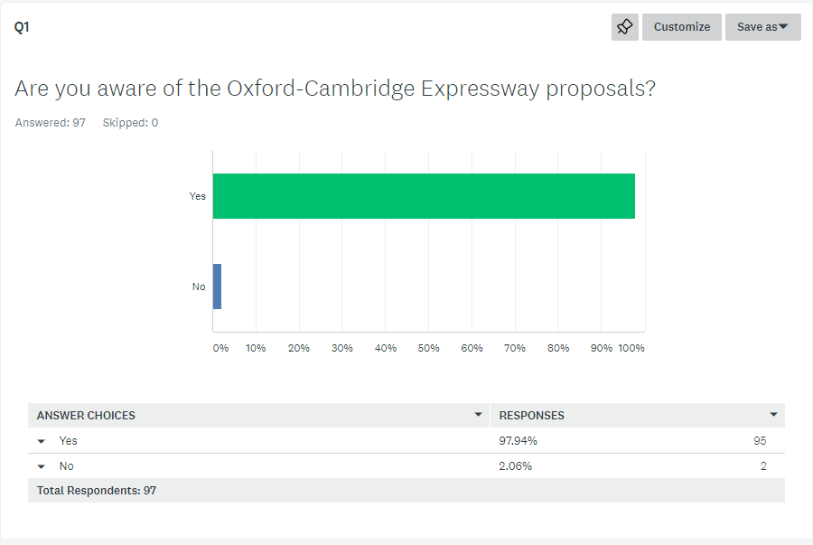

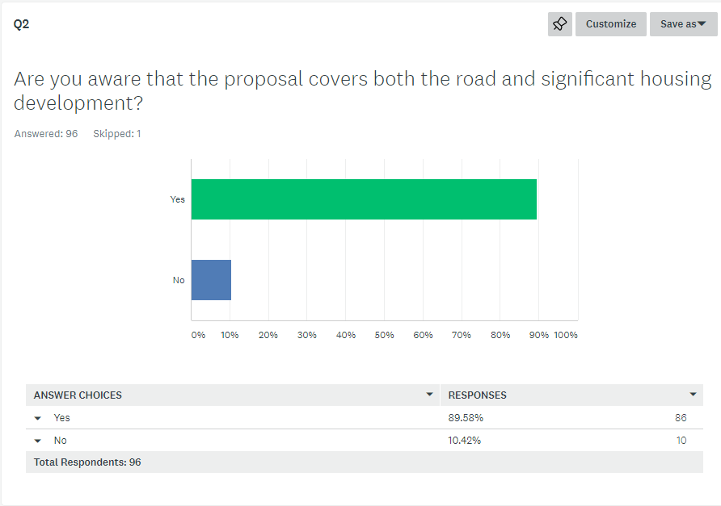
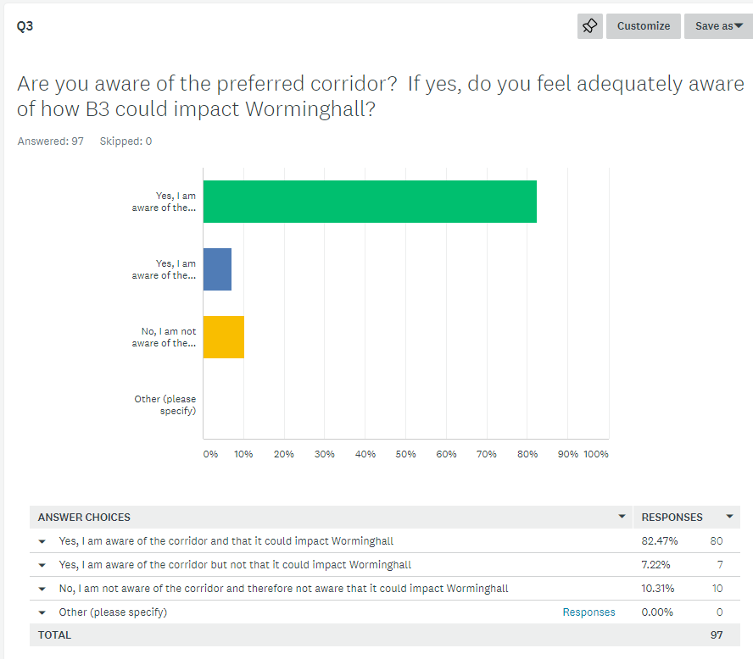
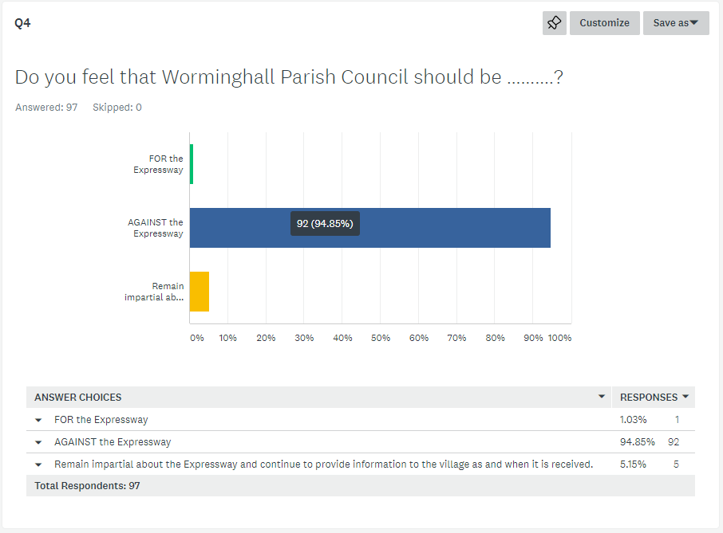
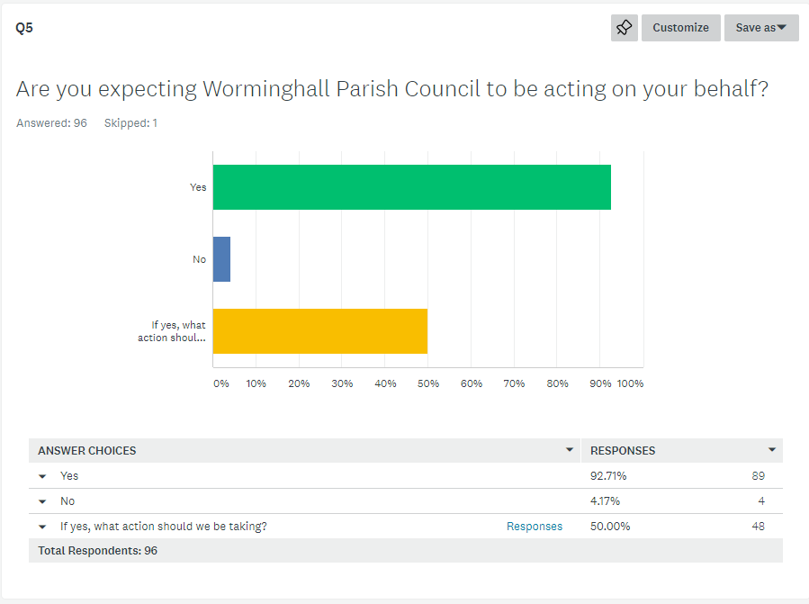
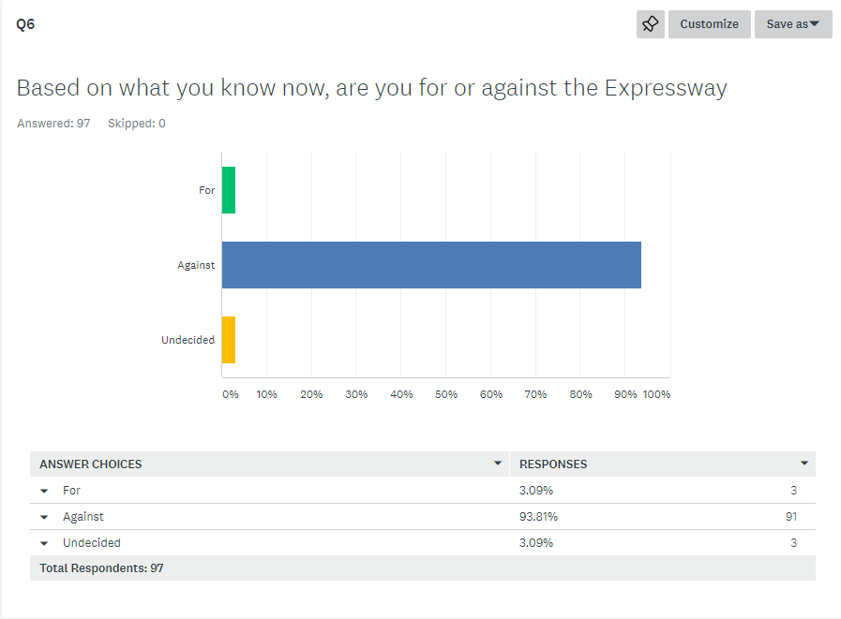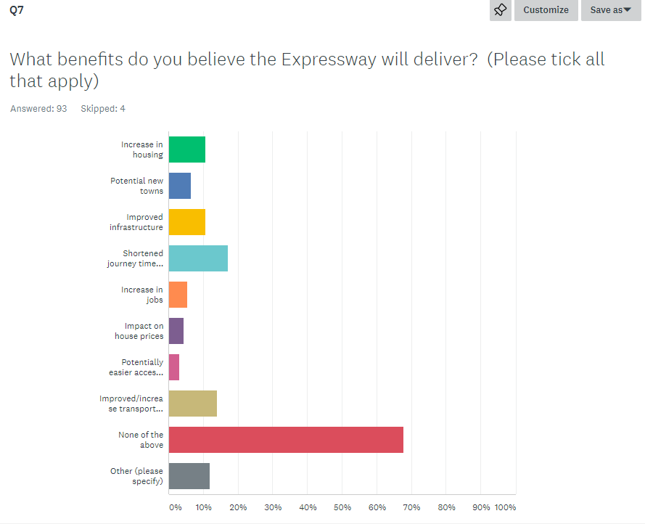
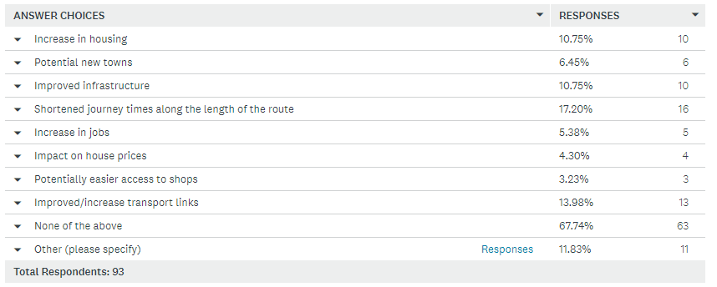

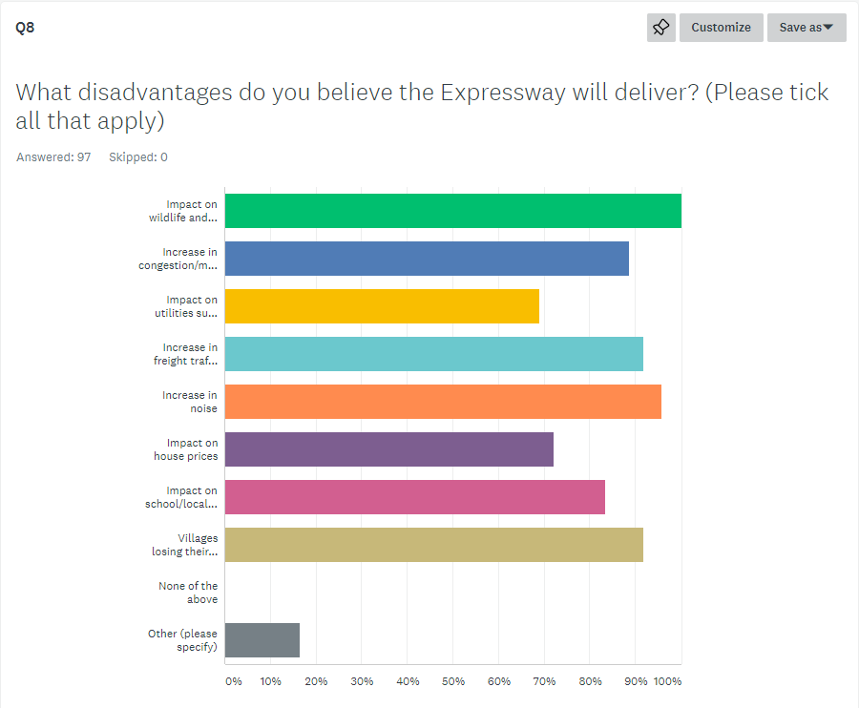

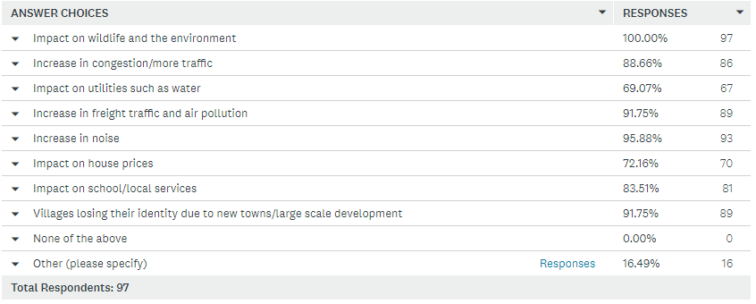

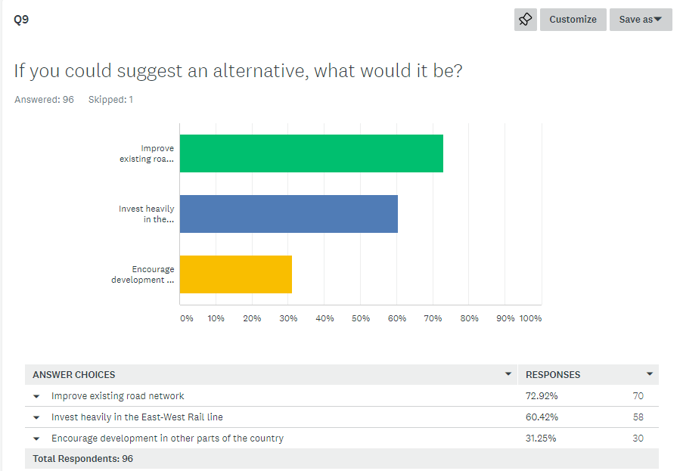
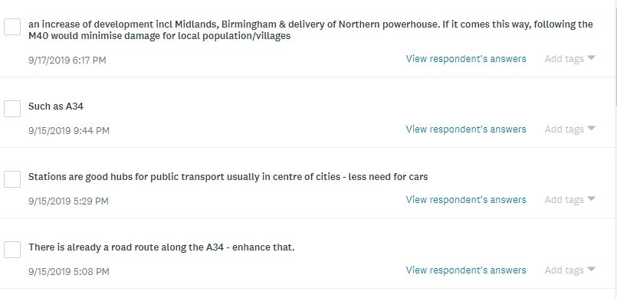
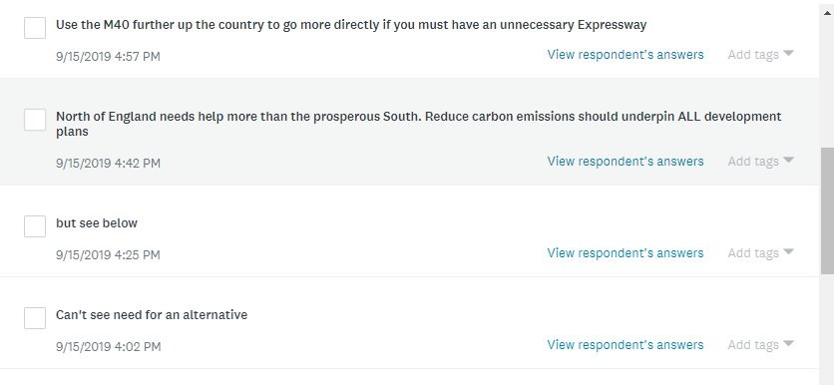
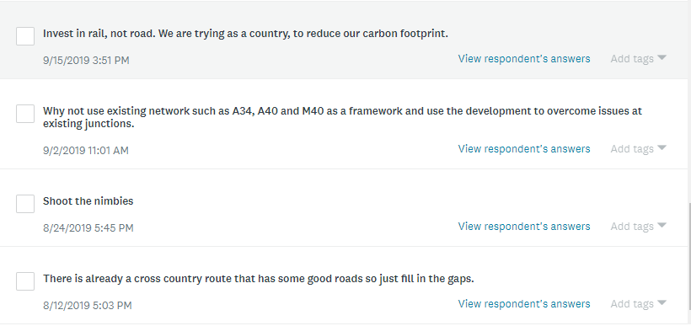

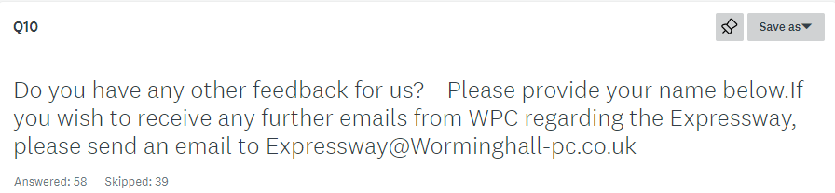

Sample of comments:
It’s not just the road that concerns us but the scale of proposed housing development associated with it.
The country as a whole needs to develop its infrastructure. This will always impact on someone. Residents look to the council to look after their interests as best they can.
We have benefitted from the M40, perhaps there will be an upside to this. Who can say? I won’t be around to see it.
If all Parish Councils, on the proposed routes united in their protests this would have more impact.
Roads are not kept in good repair now, without building more
Erosion of rights of villagers to object to impact of such schemes must be challenged.
Cutting a new road and cutting off villages and breaking up landscapes seems mad when route exists using existing roads.
This would ruin our rural community. There are too many cars on the roads as it is. The roads are terrible, it would be a disaster
The climate crisis should make any such plans for people to get anywhere as quickly as possible, obsolete. This Expressway hasn’t been thought through properly and the loss of Bernwood Forest along should merit a serious rethink.
We are seeing already, villages merging into urban sprawl. People need incentives to use the trains more and therefore investment should be concentrated in more efficient services at a reasonable cost.

